Threads

Every process starts with a main thread. We can create multiple threads along with it.

Syntax:

#include<thread> -- Library to be linked

thread <thread_name>(func_name) -- declare a thread with a call to func_name()

thread <thread_name>{func_name} -- same as above

thread <thread_name>{func_name, arg1, arg2} -- threading by passing arguments

thread <thread_name>{func_name, ref(arg1)} -- Passing arguments by reference

<thread_name>.join() -- main() func waits for the thread to complete and join.

this_thread::get_id() -- returns the thread id.

this_thread::sleep_for(time) -- delay the execution for the sleep time

**Simple Demonstration**

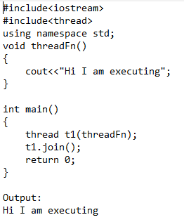

**Calling Thread Function by passing parameters**

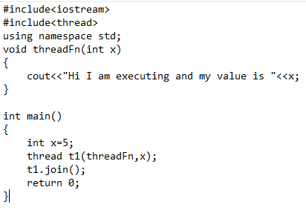

**Writing thread function in declaration**

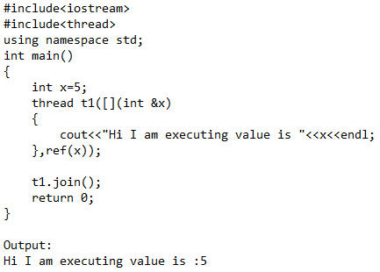

**Passing all local variables to the thread function as reference**

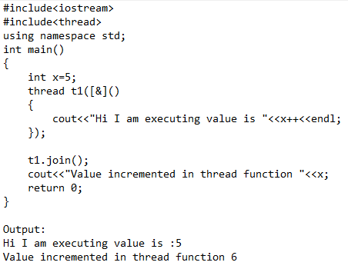

**Passing local variables but not as reference – cannot alter main function values**

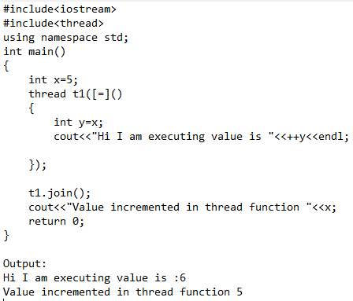

**Using join – waits the thread to complete execution**

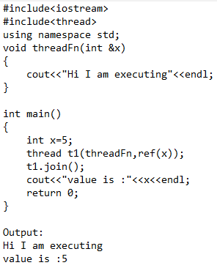

**Using join at incorrect places**

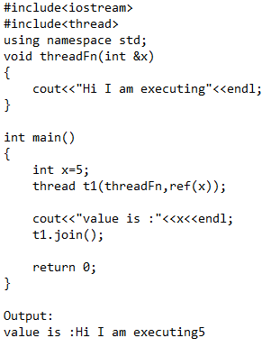

Packages supporting multithreading

Future

Promise

**Mutex lock**

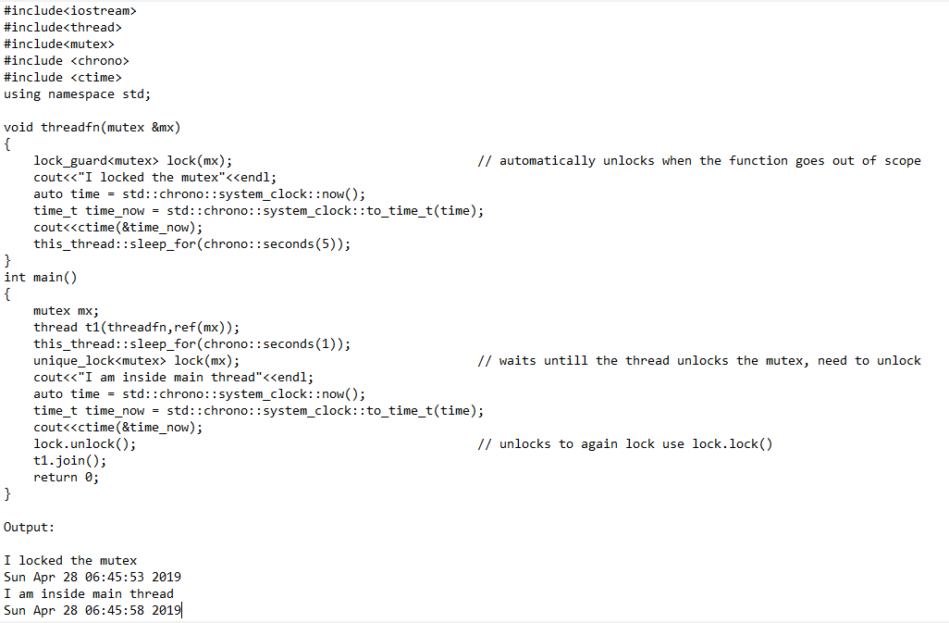

Difference between lock_guard and unique_lock?

**lock_guard** 🡪 automatically unlocks once the function goes out of scope. Cannot be used with condition variables.

unique_lock 🡪 needs to be unlocked and can be locked and unlocked. Used with condition variables.

Mutex with condition variables

<https://www.youtube.com/watch?v=kdXGTGveme8>